**Strategy Management**



**Group Project**

Group 5:

|  |  |
| --- | --- |
| NAME | A# |
| Aditya Tandon | A00432835 |
| Darshan Murugeppa | A00430884 |
| Gyaneshwar Rao Nampally | A00433014 |
| Manoj Bandaru | A00433174 |
| Sravani Choudary Madala | A00428967 |

Table of Contents

Strategy Statement: 3

Introduction: 3

Organic Growth: 3

In-Organic Growth: 3

Revenue Strategy: 4

Marketing Strategy: 5

Innovation Strategy: 6

Acquisition Strategy: 7

SWOT Analysis: 7

Recommendations: 8

Conclusion: 8

References: 9

# Strategy Statement:

Penetration into startup and open source market, increasing the cash flow using its strengths in software services by establishing its employee market in economically growing parts of the globe, repositioning into service markets using its reputation as a brand of hardware and software conglomerate and bringing up new trends in technology and innovation in AI, security and surface technology, which will help the company to move into profit zone and become influential innovator in the moving market.

# Introduction:

Blackberry Limited In the early 2010s the company started to struggle because of the high competition in the mobile phones market.

Organic Growth:

1. Blackberry has sold its naming rights to a Chinese company TCL to take advantage of low investment on production
2. In March 2019, Verizon announced that Blackberry’s acquisition Cylance’s AI-driven antivirus security solutions would integrate in its Managed Security Services Portfolio (MSS).
3. In March 2019, Blackberry Limited announced the creation of a new independent subsidiary called Blackberry Government Solutions which will help in the company’s Federal Risk and Authorization Management Program (FedRAMP) initiatives which will further strengthen the ties with the US Federal Government.
4. In March 2018, Blackberry filed a suit against Facebook for using patents on the backend. This case helped to regain some revenue back to the Blackberry.
5. In the year 2018, Blackberry has announced that it would be working with Amazon on a Blackberry Alexa device which is exclusively for the use in enterprises.
6. Blackberry has started focusing on Autonomous cars using the QNX unit. BlackBerry has already started working with some major car makers, including Ford and Hyundai, as well as some auto suppliers like Aptive and Denso.
7. Hitachi uses QNX-based platform products across the industrial control, automotive, medical and related application spaces where safety, security and reliability are of paramount importance.
8. In March 2018, BlackBerry Limited and Microsoft Corporation announced a strategic partnership with a plan BlackBerry Enterprise BRIDGE. This technology provides a way to use the different Microsoft apps in banking, defense etc.

In-Organic Growth:

1. On November 16, 2018 Cylance was purchased for US$1.4 billion by BlackBerry Limited.
2. Encription – In 2016, it has used to kickstart a new consultancy business at BlackBerry, Professional Cybersecurity Services.
3. Good Technology - In 2015, acquired and rebranded with Blackberry solutions.
4. Secusmart - Secusmart was acquired in September 2014. Acquired to make it market share stronger in security arena and exchange serving German government.

# Revenue Strategy:

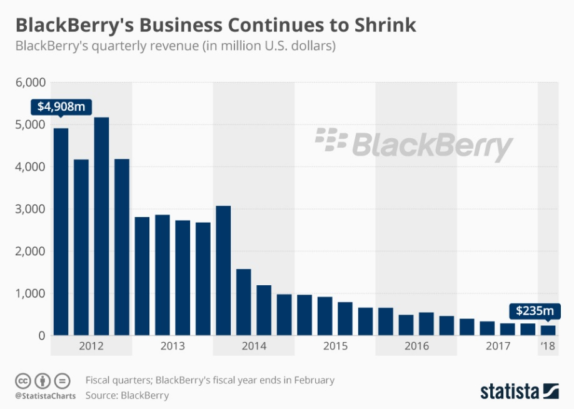

Migrating the hardware manufacturing to china, the cost of manufacturing reduces exponentially. The spending should be reduced even on the software and solutions. India, Philippines, Israel are the best countries to vouch for the software development solutions, while the consulting offices can be considered in headquarters.

* Blackberry in 2014, planned and announced that it is transforming from mobile devices to mobile solutions company, which in turn gave a 35% increase in share prices, which did not materialize later. Investors believed if the company changes from making mobile devices, to mobile solutions, it will be able to earn more profit. Then in order to generate revenue from the shares, Blackberry should evolve certain areas of the Mobile Devices manufacturing to Mobile Solutions.
* Rather than tying up with Windows in Mobile Devices, which already are in loss in this share of the market, they should focus more on Android Devices, like Moto G which was a huge success and helped blackberry regain their status in the Mobile Devices manufacturing department.
* Blackberry should sell the failed acquisitions and focus more on the successful acquisitions they have acquired.
* Innovations like BB Pin, easy accessibility for working professionals of certain things in mobile devices, should be continued, in order to gain popularity as a brand.
* Prices of products should be nominal in order to sell them in bulk and develop a brand name.

# Marketing Strategy:

Blackberry must plan for upcoming technologies in advance, prepare and get into market with its products at right time. For eg, 5G is the upcoming advance telecommunication technology and blackberry must act upon it as early as possible.

Blackberry is known for security; hence they can tie up with android supportive mobile companies to integrate blackberry security, which could give tough competition to IOS.

Selling blackberry phones through Verizon marketing channel is the better way to get into larger community of people (businesses). The QNX operating system should be open sourced and black berry must take advantage of the open source community like the other big organizations for improving their strength in software services and grabbing interest in the market and have its own developer community.

Black berry must involve in university programs and get connected with the students to maintain its brand value in the coming decades. Blackberry must identify features that attract youth and promote them.

Blackberry has required infrastructure and can give a thought to utilize block chain technology and provide services.

The bar chart below illustrates that software segment will drive earnings forward:

|  |  |
| --- | --- |
|  |  |
| Software Revenue | Software Profit Margin |

**QNX traction everywhere** QNX controls about half the market for infotainment systems and yields about $1 to $1.50 per vehicle. The company could ultimately make about $5 a vehicle with recurring revenue models. QNX's software platform works with ARM, Intel. QNX is positioned as an OS for IOT and autonomous driving platform with better security.

# Innovation Strategy:

**AI in Cars:** Innovating in artificial intelligent stream for cars and making deals with jaguar for entering this segment is a great advantage for innovation and practical implementation into production environment, leads to further marketing strategy with other dealers.

**IOT OS:** An operating system which fits the IOT eco system would enhance the popularity of the blackberry brand name and its sales.

**Material Science, Mobile Keyboard:** Blackberry is known for its mobile keyboard experience but there is not much innovation in this sector. Blackberry must investigate into interesting technologies happening in MIT with dynamic surfaces which can pull blackberry into markets like digital e-commerce shopping experience (where simulation of cloth material can be made possible) and having a unique and dynamic keyboard which can alter its nature according to the application. Innovation should be encouraged in the field and blackberry has this feature to be of paramount priority.

Open Source

QNX OS with IOT

AI car and open source involvement

Dynamic Keyboard , Material Science

Innovation Strategy

|  |  |
| --- | --- |
| Polymer material produced by a 3-D printer includes soft, flexible material (clear or lighter tone) with particles of hard material (black) embedded, in predetermined arrangements. When the material is compressed, its surface become bumpy in a pattern determined by the hard particles. | Polymer material produced by a 3-D printer includes flexible and soft, flexible surface material with bits/particles of hard material (black). When the material is squeezed, its surface can simulate a key or a shape. |

# Acquisition Strategy:

BlackBerry has lost its ability to procure new patents or start-ups due to financial issues. It has that ability when it is in success paths and invested on innovative ideas, now they lost the ability. If they re structure their finance and security, it might get the ability to research for acquisitions and can improve future of the company.

During the last decade, BlackBerry made several acquisitions to add features and improve offerings through its products, including QNX, Scroon, Scoreloop, and Gist. Such developments were reflected in stock price swings. Black berry is mainly focusing on security implementation.

BlackBerry’s human resources has taken a big hit because of its financial losses and failure of product. In the process of cutting their workforce, it focused on firing the employees to cut loose costs. This obviously raised job insecurity in the employees and started moving for similar role in another companies. One such case is their former CEO Thornstein Heins.

The security must spread into space research and integrate with blue origin and SpaceX. The strength of having hardware and software manufactured by itself, it has a strong reputation for optimized devices and can integrate itself with customized android with its security features which is attractive enough for the present youth with good price points.

# SWOT Analysis:

|  |  |
| --- | --- |
|  |  |
|  |  |
| **SWOT Analysis for BlackBerry** | |
| **Strengths** | **Weakness** |
|  |  |
| * BBM Fame | * Degrading Market Share |
| * Valuable Patents | * High paying applications in OS |
| * Historical Brand | * Low Employees |
| * Good Cash pile | * Uncertainty of Leadership |
|  | * No sales for new products |
|  | * Large Financial Losses |
|  |  |
|  |  |
| **Opportunities** | **Threats** |
|  |  |
| * Capability for innovation | * Bankruptcy |
| * Opportunity for new ownership | * High Competitors for Mobile brands |
|  | * No extra Funding |
|  | * Less Market Share |

# Recommendations:

BlackBerry, once a dominant cellphone maker, lost its market share and brand value. This is because of its fault technology and no innovation. Our recommendations are based on what can be done in near future, with financing in acquired.

BlackBerry should concentrate on main production line and investigate if there are mobiles flaws such as camera use, text messaging, etc... These flaws should be studied and fixed before working on other products. While they also must begin to differentiate their QWERTY – keyboard and full touchscreen phones, it should commit it more on innovation and functional devices with no physical keyboard. Integration with computers and smart watches will help BlackBerry create a single, unique device.

BlackBerry should work on OS flaws. We can take an example of Microsoft windows, Microsoft launched windows 8 and it soon met with many flaws and everyone said that it ‘failed’. Microsoft quickly acknowledge and worked on it to build a new upgrade to fix all issues. They set a relaunch and delivered to customers for free of cost. BlackBerry should take similar path and upgrading OS for older phones.

The Other flaw with BB OS is the application support. We can see Google play store and Apple iTunes store thousand of apps. These apps can be downloaded in millions and encouraging developers and start-ups. So, BlackBerry should concentrate more on application support and should be par with competitors

Finally, BlackBerry’s strategy must be to innovate and stay on trend in mobile industry. In the competitive market BB has fallen behind for not being useful to customers or no urge for customers to buy the mobile with BB OS. Where the keyboard once a focal point, but now customers have easily made transition to on-screen keyboards for their full-touchscreen smartphones. BB’s Z10 and Z30 became competitors for current touchscreen phones but lacked the application support. So, they should work on the application support to stand out. Currently, there is a ‘wearable technology’ trend beginning with smart watches , BB must find a way and capitalize in time and force the competitors out of the market.

# Conclusion:

As by our analysis, to regain the glory of BlackBerry, it must keep a track of 4 things:

* Threat of New Entry
* Competitive Rivalry
* Supplier Power
* Buyer Power

BlackBerry needs restructuring and re-evaluation. It has already done the layoff which helped to cut the staff that are set in old ways of company. BlackBerry services are widely been used but its cellphones are sitting in the shelves for a long time, with a competitive strategic plan on the department of mobiles, and a do or die mentality in the management, it can regain the former glory in mobile industry.

# References:

1. BlackBerry Limited. (2019, July 15). Retrieved from https://en.wikipedia.org/wiki/BlackBerry_Limited
2. Thecanadianencyclopedia.ca. (2019). *BlackBerry Limited | The Canadian Encyclopedia*. Available at: https://www.thecanadianencyclopedia.ca/en/article/blackberry-limited.
3. Ramstad, J. (2018, December 21). BlackBerry Handset Revenue Was $0, Marking the End of An Era. Retrieved from https://www.androidheadlines.com/2018/12/blackberry-smartphones-sales.html https://www.androidauthority.com/blackberry-tcl-2019-946818/
4. Blackberry.com. (2019). *BlackBerry’s Growing Global Partner and Channel Ecosystem to Help Drive Adoption of BlackBerry Spark – the Company’s New EoT Platform*. [online] Available at: https://www.blackberry.com/us/en/company/newsroom/press-releases/2018/blackberrys-growing-global-partner-and-channel-ecosystem-to-help-drive-adoption-of-blackberry-spark.
5. Slideshare.net. (2019). *BlackBerry Case Study - November 2013*. [online] Available at: https://www.slideshare.net/EvanHallward/blackberry-case-study-november-2013-61254331?from_action=save [Accessed 24 Jul. 2019].
6. Blackberry.com. (2019). *Verizon Expands Managed Security Services Portfolio with BlackBerry Cylance AI-Based Endpoint Security*. [online] Available at: https://www.blackberry.com/uk/en/company/newsroom/press-releases/2019/verizon-expands-managed-security-services-portfolio-with-blackberry-cylance
7. BlackBerry deepens ties to U.S. government with new subsidiary. (2019). *BlackBerry deepens ties to U.S. government with new subsidiary*. [online] Available at: https://theworldnews.net/ca-news/blackberry-deepens-ties-to-u-s-government-with-new-subsidiary.
8. Sun, L. (2019). *BlackBerry Moves to Make Money from Its Patents -- The Motley Fool*. [online] The Motley Fool. Available at: https://www.fool.com/investing/2018/09/14/blackberry-moves-to-make-money-from-its-patents.asp
9. Jackson, B. (2019). *BlackBerry is working with Amazon on an Alexa device for the enterprise*. [online] IT World Canada. Available at: https://www.itworldcanada.com/article/blackberry-is-working-with-amazon-on-an-alexa-device-for-the-enterprise/409669
10. Office, D. (2019). *Surfaces get smooth or bumpy on demand*. [online] MIT News. Available at: http://news.mit.edu/2015/controllable-surface-textures-0611